**Question 1, A and B: The explanation for code and results, Question, A and B is the same and it is written below.**

The provided MATLAB code calculates the centered finite difference approximation of the second derivative f''(x) for the given function (A) on the interval ([-1, 1]). It then plots both the analytical and numerical results for a fixed grid size (h = 0.02). I will explain the different parts of the code below:

1. Function Definition: The code defines the function f(x) using element-wise operators, which is necessary for numerical calculations involving arrays.

2. Grid Generation: It generates a set of grid points (x) within the interval ([-1, 1]) using the fixed grid size (h = 0.02) for plotting and analyzing the numerical and analytical part. These grid points represent discrete values of (x) at which the function will be evaluated.

3. Analytical Result: The analytical second derivative f''(x) of the function f(x) is computed analytically. This exact result is derived mathematically and represents the ideal, theoretically accurate solution.

4. Numerical Approximation: The code then calculates the centered finite difference approximation of the second derivative f''(x) using the defined grid and the formula for centered finite differences. This approximation provides an estimate of f''(x) based on discrete data points and is subject to numerical errors.

5. Error Calculation: The code calculates the absolute error between the analytical and numerical results at each grid point (x). The error represents the numerical deviation of the approximation from the exact solution. Then, I wrote a code that performs linear regression to estimate the order of error in a log-log plot in order to make sure whether my results are resealable or not.

To accurately determine the order of error, I fitted a line to the log-log plot of errors versus grid sizes and found the slope/order of that line/error. The order of error for A, and B is shown below.

**The results:**

1. Plot Explanation:

- The first plot displays two curves: the canyon (A)/yellow (B) curve represents the analytical solution of function and the pink (A)/black (B) dashed curve represents the numerical approximation of f''(x) using a centered finite difference method.

- The x-axis represents the values of (x) in the interval ([-1, 1]), and the y-axis represents the corresponding values of f''(x).

- The legend in the plot identifies the curve as the "Analytical" result and the dashed curve as the "Numerical" approximation.

2. Importance of the Plot:

- The plot is essential because it visually illustrates the agreement or discrepancy between the numerical approximation and the exact analytical solution. Any discrepancies between the two curves highlight areas where the numerical approximation deviates from the analytical solution. This can help pinpoint regions where the numerical method may need improvement. In this question the numerical approximation and exact analytical are very similar.

- It allows us to assess how well the numerical method captures the behavior of the function's second derivative over the specified interval.

- The plot helps us determine the optimal grid size for our specific problem. Smaller grid sizes tend to yield more accurate results, but they also require more computational resources. Therefore, this analysis helps strike a balance between accuracy and computational cost.

3. Comparison of Numerical and Analytical Solutions:

- The comparison is crucial because it helps validate the accuracy of the numerical method.

- The analytical solution is considered the "gold standard" or the true solution derived from mathematics, and it serves as a reference for assessing the quality of the numerical approximation.

- Discrepancies between the two curves can highlight areas where the numerical method may introduce errors or where further refinement is needed.

4. Error Plot and Significance:

- The second plot, the log-log error plot, provides insight into the behavior of the error as a function of the grid size (h).

- Each point on the error plot corresponds to a specific grid size (4 different grid sizes), and the y-axis represents the absolute error between the numerical and analytical solutions.

- The error plot is crucial for understanding the convergence behavior of the numerical method.

- It reveals that the numerical approximation becomes more accurate as the grid size decreases.

- Smaller errors for smaller grid sizes suggest that the numerical approximation converges to the exact solution as the grid becomes finer. This analysis is essential for understanding the reliability and accuracy of numerical methods used in scientific computing and engineering applications.

- The steeper the slope of the error curve in the log-log plot, the faster the error decreases as the grid size decreases. Conversely, a shallower slope suggests slower convergence.

5. Improving Numerical Approximation:

- The error plot can indicate whether the numerical approximation can be improved.

- The numerical approximation can be improved in the following ways:

1. Finer Grids: To achieve higher accuracy, one can decrease the grid size (h). Smaller grid sizes lead to smaller errors, as shown by the decreasing trend in the log-log plot. However, this comes at the cost of increased computational resources and time.

2. Higher-Order Methods: Instead of the centered finite difference scheme used here (which is second-order accurate), higher-order finite difference methods can be employed.

3. Adaptive Grids: Implementing adaptive grid refinement techniques can automatically adjust the grid size in regions where accuracy is critical. This optimizes computational resources by using finer grids only where needed.

4. Alternative Numerical Methods: Exploring alternative numerical methods, such as finite element or spectral methods, may provide better accuracy for specific types of problems.

Question 1, A: The results

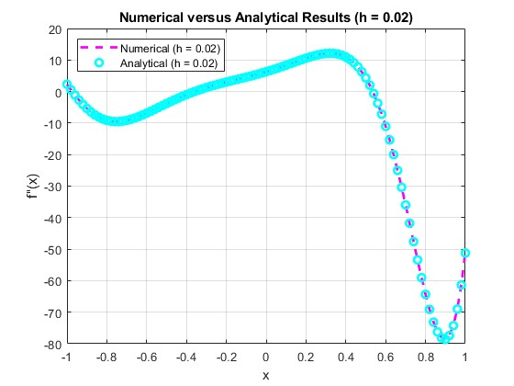

Numerical vs. Analytical Results (A)

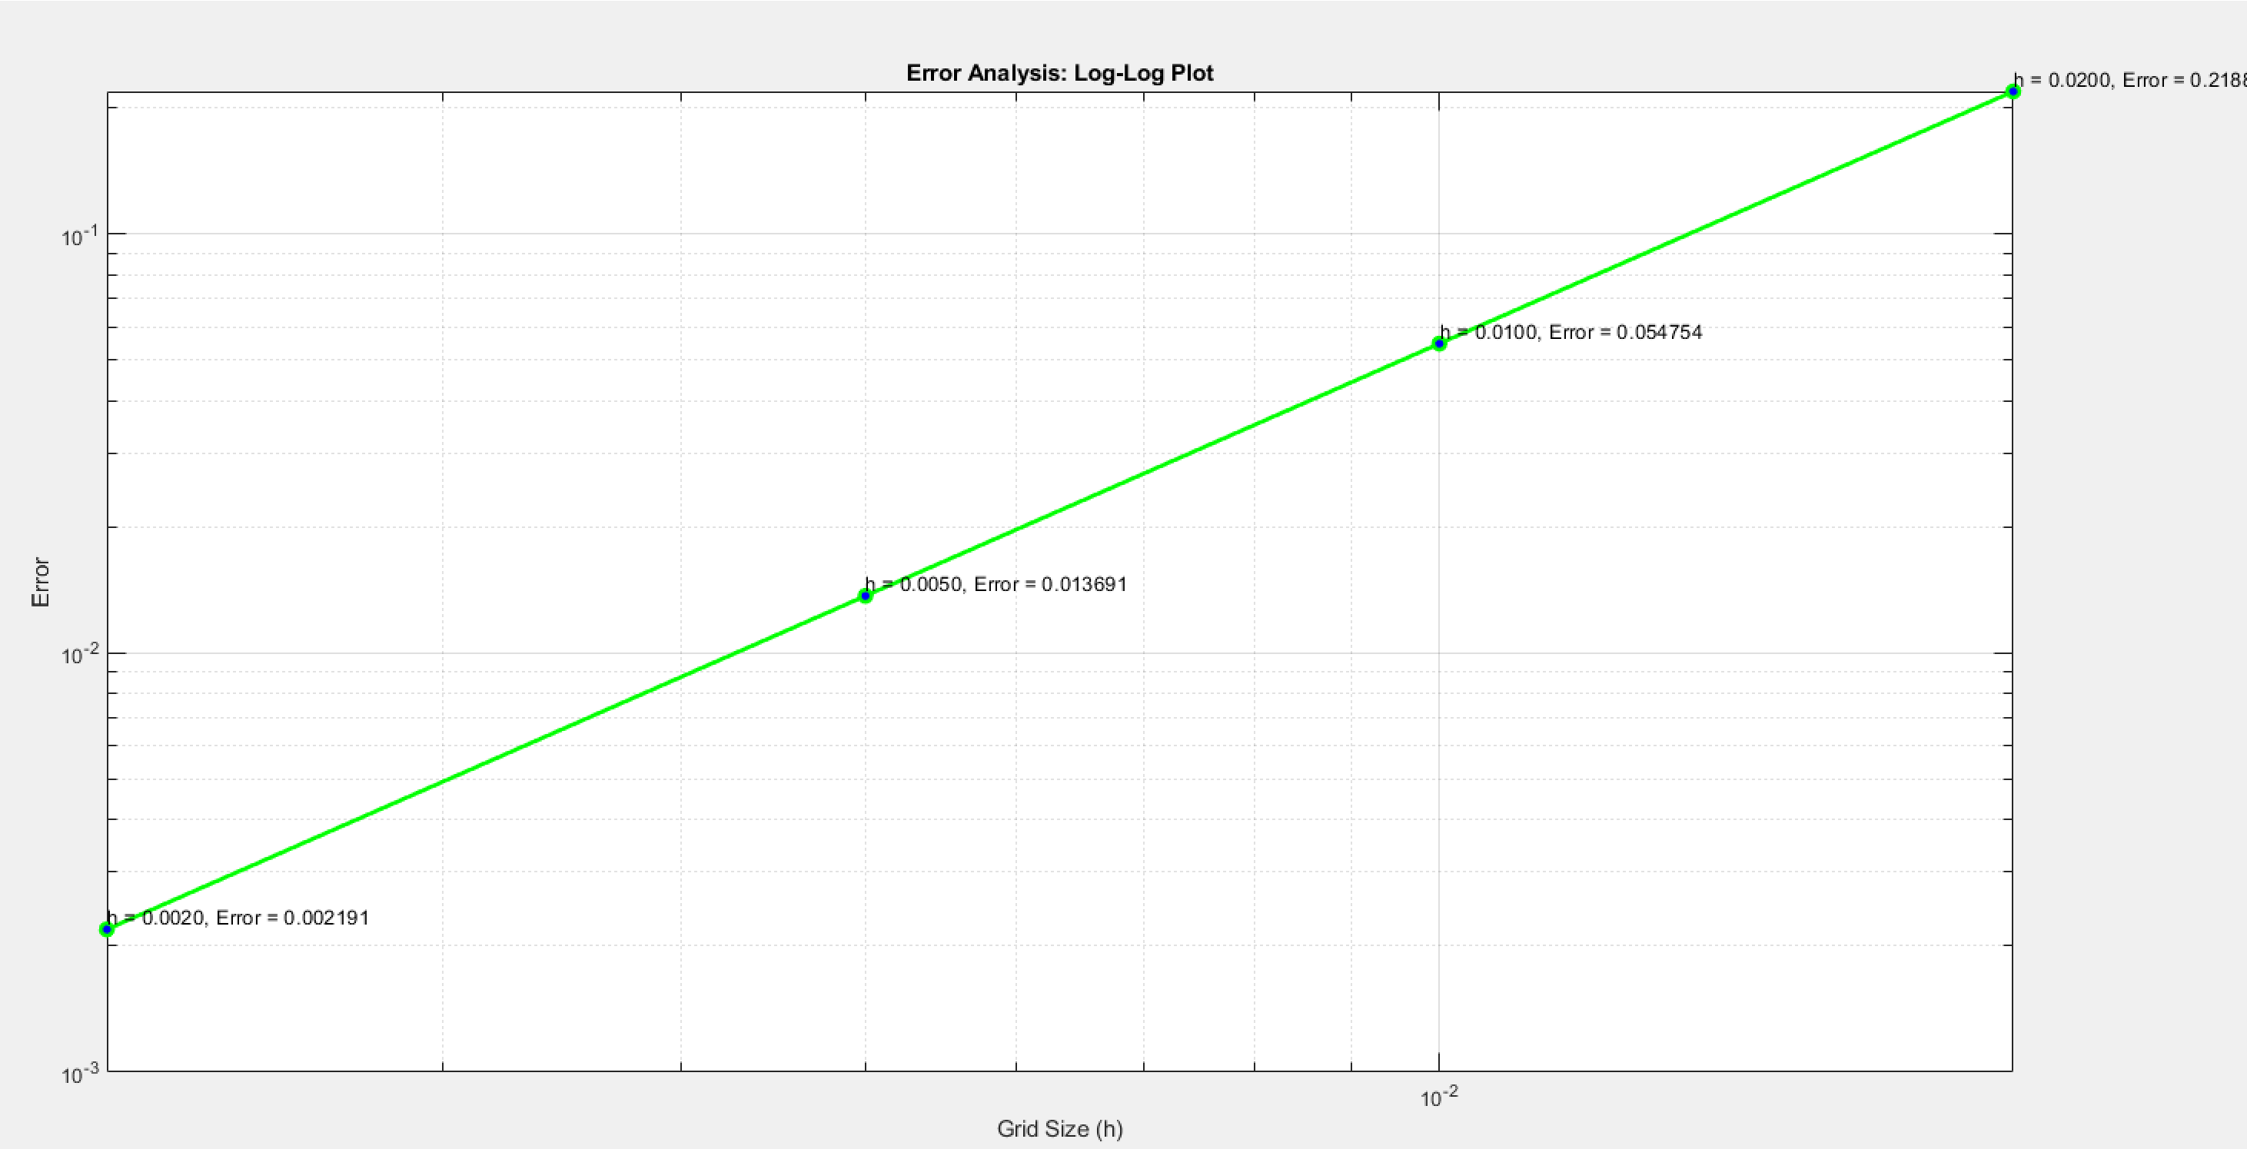

Error Analysis (A)

The order of error for function A: The error is second order.



Question 1, B: The result

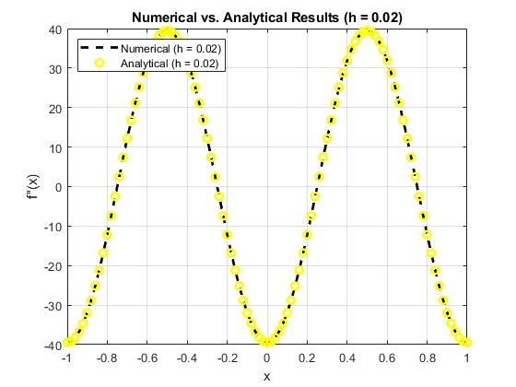

Numerical vs. Analytical Results (A)

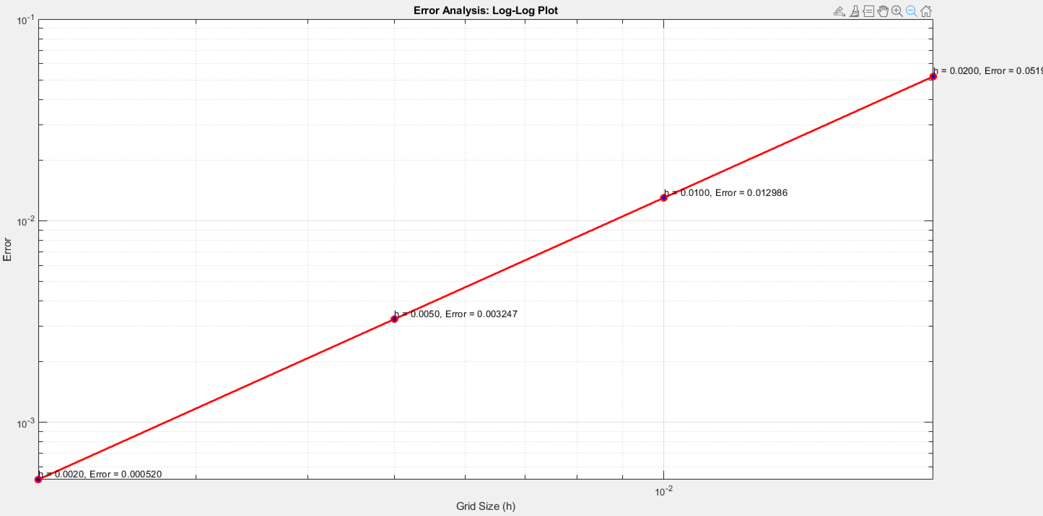

Error Analysis (A)

The order of error for function B: The error is second order.

